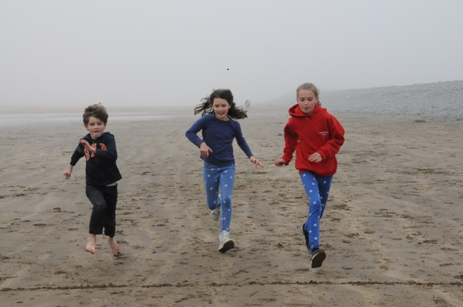

Becoming a volunteer with children, young people or vulnerable adults at All Saints

Issue 1: October 2018

Introduction

Thank you for applying to join the children, young people or vulnerable adults volunteer team at All Saints, Nettleham – we are delighted that you want to be involved with this work.

Working with children, young people and vulnerable adults is an important part of the life of the church. We take the appointment and support of our volunteers very seriously. We want to make sure that we make good volunteer appointments, and therefore need to know something about you before you can take up your role. There are also some legal requirements that have to be met as part of the appointment process. Please be assured that all information supplied by you will be held in strictest confidence, and seen only by the individuals appointed by the Parochial Church Council (PCC) to manage the process. If you have any questions, please do talk to one of the key contacts listed overleaf.

All volunteer appointments are approved by the PCC. This leaflet explains how the appointment process works and sets out the information that is required.

Applying to be a volunteer

Stage 1 – Completion of the Volunteer Application Form and Confidential Declaration Form (The Safer Recruitment Officer manages this process)
The forms can be downloaded from the church website, or your group leader can provide a soft or hard copy. You are asked to provide basic information about yourself, including any relevant training or experience that you may have had. Previous experience is not an essential requirement – we are very happy to support you in developing your skills.

The Confidential Declaration Form asks you to declare any past criminal convictions or issues in relation to the protection of children or vulnerable adults. Please answer this declaration fully. If you are answering ‘yes’ to any of these questions, please contact the Safeguarding Officer to discuss the implications. Depending on the circumstances, it will not necessarily bar you from being appointed.
References: In the Application Form, we ask you to provide the names of two people who we can approach to provide a reference. Your referees should be people who know you well and should not be relatives, members of staff at this church, or the person you will be reporting to in your volunteer role. Examples might be a former vicar or youth leader, a friend within the church or elsewhere, or a current or a past work colleague. We do follow up your references, so please make sure that the contact details you provide are correct, and do let your referees know that we will be contacting them.

Please complete and return the application form and confidential declaration form to the Safer Recruitment Officer within 2 weeks of receiving it. (You can either email it, or leave in the pigeon holes at the back of church)

Stage 2 - Disclosure and Barring Service (DBS) Check

We are legally required to obtain Disclosure and Barring Service (DBS) clearance for all volunteer applications. The DBS is a government body that checks that an applicant does not have a criminal record. The DBS Officer manages this process, which includes an ID check.

Stage 3 – Sign-Off Meeting

Once we have checked your references, and obtained DBS clearance, the final stage is for you to meet with the Safer Recruitment Officer. The purpose of this meeting is to make sure that you are comfortable with the role you have been asked to take on, to answer any questions that you may have, and to discuss any training or support that may be appropriate. A member of the PCC will attend this meeting.

Regular training and supervision

We will provide you with a clear volunteer role description and you will have a group leader to go to for support and guidance. Regular safeguarding training with be provided by the church and volunteers need to attend this on a three yearly basis to ensure they are aware of current best practice for supporting and safeguarding children and vulnerable adults.

Summary of appointment process for volunteers

Complete Application Form and Confidential declaration and send to Safer Recruitment Officer
DBS Officer contacts you to check ID and initiate DBS clearance process

PCC approves the appointment
Safer Recruitment Officer contacts you to arrange Sign-Off meeting

Begin your volunteer role, supported by your Group Leader
Discuss proposed role with member of the Staff Team
KEY CONTACTS

Russ Coulter acts as the Parish Safeguarding Officers, and also manage the recruitment and DBS processes for volunteers. Please contact them for any questions or concerns relating to volunteer recruitment, or safeguarding issues.
They can be contacted at Safeguarding@asn.church

